**Stage 3**

**RULES:** USPSA Competition Rules, Latest Edition **COURSE DESIGNER:** Ike Starnes

|  |  |
| --- | --- |
| **START POSITION: See written stage briefing.** | |
| **STAGE PROCEDURE**  See written stage briefing. | **SCORING**  **SCORING:** Comstock 28 rounds.  **TARGETS:** There are 13 cardboard targets and 2 steel poppers.  **SCORED HITS:** 2 Best hits per carboard will be scored, steel must fall to score.  **START-STOP:**  Audible - Last shot  **PENALTIES:** Per USPSA Competition Rules |

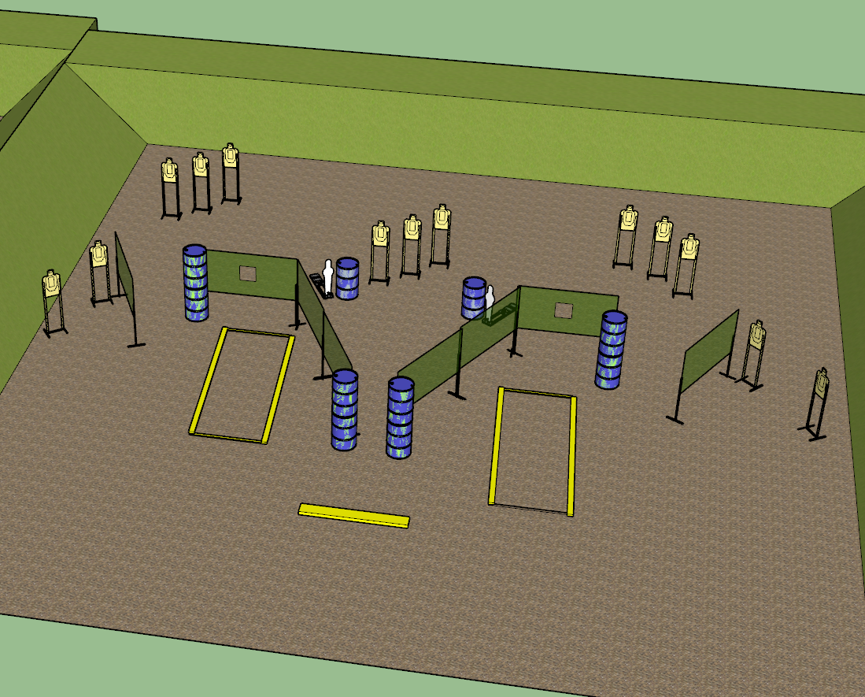

**Written Stage Briefing:**

**Stage 3 –** is a 28-round, 140 point, Comstock Long Course. There are 13 cardboard targets and 2 steel targets. The best 2 hits per cardboard target will be scored. The steel targets must fall to score. The balance beam is part of the shooting area.

**Start position** Standing anywhere inside the shooting area.

Handgun: Loaded and holstered with both wrists below belt.

PCC: Loaded, held in both hands, safety on, muzzle pointed directly downrange.

On the audible start signal, engage targets from within the shooting area.

**Setup Notes:**

Build the center shooting area to a width of about 18”.

Ensure steel targets are at least 26 feet away from ends of center shooting area.

Ensure middle targets are NOT visible from a single location in the center shooting area.

Ensure steel targets are NOT visible from the ports (use extra barrels if needed).